**CHAPTER 1**

**INTRODUCTION**

**1.1 INTRODUCTION TO PROJECT**

Indian Railway Catering and Tourism Corporation popularly known as IRCTC is an Indian public sector undertaking that provides ticketing, catering, and tourism services for the Indian Railways.

Our project "IRCTC railway reservation" is a desktop based standalone application developed using java swings framework of java.

This project is an attempt to demonstrate the working of railway reservation process both from the admin and user view. All the functionalities which are provided by the IRCTC website and app are implemented in the form of desktop application which is very simple and easy to use.

The user interface is attracting and doesn't confuse users in completing their booking process.

**1.2 PROJECT OBJECTIVE**

The main objective of the project is to implement the desktop version of IRCTC mobile application which provides all the functionalities in desktop.

A complete and efficient desktop application which can provide a good and user friendly experience is the basic objective of the project.

**1.3 PROJECT OVERVIEW**

The central concept of the application is to allow the users to book tickets virtually using the Internet. The information pertaining to the trains, stations, cost, time and all other necessary details are stored in the database in the form of tables following the rules of RDBMS (Relational database management system).

The application process the users request and sends the ticket to their registered e-mail Id where the user doesn't need any hard copy of the ticket to travel in the train. The application is designed into two modules, first is for the users who wish to book the tickets. Second is for

the admin who maintains and updates the information pertaining to the trains and their respective schedules and even those of the customers. The end user of this product is the customer where the application is hosted on the desktop as standalone and the administrator maintains the database.

The application which is deployed at the user database, the details of the trains and personal information are brought forward from the database for the user view based on the selection through the menu and the database of all the trains such as updating the available seats after each booking and updating the bookings table after each booking is completed successfully. Data entry into the application can be done through various screens designed for various levels of end users (admin and customer).

**1.4 PROJECT SCOPE**

This system can be implemented in any desktop which complete the requirements in order to user the application. The system recommends a facility to accept the bookings 24*7 and online ticket issuing system which decreases the effort of customers to take the offline ticket issued at the station. This system also decreases the effort of the railways to appoint more employee to issue tickets.

The railways also doesn't lose their customers and even are also happy by their decrease of effort. Since the application is available in the desktop it is easily accessible and always available.

PNR status is one of the important feature where the users can track their booking status by entering their 10 digit number which shows all the details of the passengers travelling in the booked train which also shows the seat number which can be updated when there is some changes in the operation of the train.

#### **1.5 INTRODUCTION TO DATABASE**

Databases and database technology have had a major impact on the growing use of computers. A database is a collection of related data. By data, we mean known facts that can be recorded and that have implicit meaning. For example, consider the names, telephone numbers, and addresses of the people you know. Nowadays, this data is typically stored in mobile phones, which have their own simple database software. In other words, a database has some source from which data is derived, some degree of interaction with events in the real world, and an audience that is actively interested in its contents. A database can be of any size and

complexity. For example, the list of names and addresses referred to earlier may consist of only a few hundred records, each with a simple structure. On the other hand, the computerized catalogue of a large library may contain half a million entries organized under different categories.

A database has the following implicit properties:

1. A database represents some aspect of the real world, sometimes called the mini world or the universe of discourse. Changes to the mini world are reflected in the database.
2. A database is a logically coherent collection of data with some inherent meaning. A random assortment of data cannot correctly be referred to as a database.
3. A database is designed, built, and populated with data for a specific purpose. It has an intended group of users and some preconceived applications in which these users are interested.

A database management system (DBMS) is a computerized system that enables users to create and maintain a database. The DBMS is a general-purpose software system that facilitates the processes of defining, constructing, manipulating, and sharing databases among various users and applications. Defining a database involves specifying the data types, structures, and constraints of the data to be stored in the database. The database definition or descriptive information is also stored by the DBMS in the form of a database catalogue or dictionary; it is called meta-data. Constructing the database is the process of storing the data on some storage medium that is controlled by the DBMS. Sharing a database allows multiple users and programs to access the database simultaneously.

#### **1.6 HISTORY OF DBMS**

Data is a collection of facts and figures. The data collection was increasing day to day and they needed to be stored in a device or a software which is safer.

Charles Bachman was the first person to develop the Integrated Data Store (IDS) which was based on network data model for which he was inaugurated with the Turing Award (The most prestigious award which is equivalent to Nobel Prize in the field of Computer Science.). It was developed in early 1960’s.

In the late 1960’s, IBM (International Business Machines Corporation) developed the Integrated Management Systems which is the standard database system used till date in many places. It was developed based on the hierarchical database model. It was during the year 1970 that the [relational database model](https://www.geeksforgeeks.org/relational-model-in-dbms/) was developed by Edgar Codd. Many of the database models we use today are relational based. It was considered the standardized database model from then.

The relational model was still in use by many people in the market. Later during the same decade (1980’s), IBM developed the [Structured Query Language (SQL)](https://www.geeksforgeeks.org/structured-query-language/) as a part of R project. It was declared as a standard language for the queries by ISO and ANSI. The Transaction Management Systems for processing transactions was also developed by James Gray for which he was felicitated the Turing Award.

Further, there were many other models with rich features like complex queries, datatypes to insert images and many others. The Internet Age has perhaps influenced the data models much more. Data models were developed using object oriented programming features, embedding with scripting languages like [Hyper Text Markup Language (HTML)](https://www.geeksforgeeks.org/html-introduction/) for queries. With humongous data being available online, DBMS is gaining more significance day by day.

**1.7 ADVANTAGES OF DBMS**

Compared to the File Based Data Management System, Database Management System has many advantages.

##### **1. Reducing Data Redundancy**

The file-based data management systems contained multiple files that were stored in many different locations in a system or even across multiple systems. Because of this, there were sometimes multiple copies of the same file which leads to data redundancy. This is prevented in a database as there is a single database and any change in it is reflected immediately. Because of this, there is no chance of encountering duplicate data.

##### **2. Data Integrity**

Data integrity means that the data is accurate and consistent in the database. Data Integrity is very important as there are multiple databases in a DBMS. All of these databases contain data that is visible to multiple users.

So, it is necessary to ensure that the data is correct and consistent in all the databases and for all the users.

##### **3. Data Security**

Data Security is vital concept in a database. Only authorized users should be allowed to access the database and their identity should be authenticated using a username and password. Unauthorized users should not be allowed to access the database under any circumstances as it violates the integrity constraints.

##### **4. Privacy**

The privacy rule in a database means only the authorized users can access a database according to its privacy constraints. There are levels of database access and a user can only view the data he is allowed to. For example - In social networking sites, access constraints are different for different accounts a user may want to access.

##### **5. Backup and Recovery**

Database Management System automatically takes care of backup and recovery. The users don't need to backup data periodically because this is taken care of by the DBMS. Moreover, it also restores the database after a crash or system failure to its previous condition.

##### **6. Data Consistency**

Data consistency is ensured in a database because there is no data redundancy. All data appears consistently across the database and the data is same for all the users viewing the database. Moreover, any changes made to the database are immediately reflected to all the users and there is no data inconsistency.

##### **1.8 COMPONENTS OF DBMS**

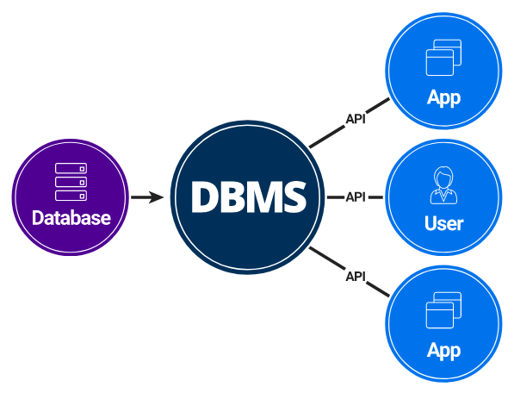

**Fig 1.1 Components of DBMS**

Fig 1.1 shows the components of DBMS which describe the different parts that work together for creating, managing the database that forms a complete system named DBMS (database management system).

1. **Users**:

Users may be of any kind, such as data base administrators, system developers or database users.

1. **Database application**:

Database application may be Departmental, Personal, Organizational and /or Internal.

1. **DBMS**:

Software that allows users to create and manipulate database access.

1. **Database**:

Collection of logical data as a single unit.

**1.9 CONSTRAINTS**

Mainly Constraints on the relational database are of 4 types:

1. Domain constraints
2. Key constraints
3. Entity Integrity constraints
4. Referential integrity constraints

**1. Domain Constraints:**

* Every domain must contain atomic values (smallest indivisible units) it means composite and multivalued attributes are not allowed.
* We perform datatype check here, which means when we assign a data type to a column we limit the values that it can contain.
* Ex. If we assign the datatype of attribute age as int, we can’t give it values other than int datatype.

**2. Key Constraints or Uniqueness Constraints:**

* These are called uniqueness constraints since it ensures that every tuple in the relation should be unique.
* A relation can have multiple keys or candidate keys(minimal super key), out of which we choose one of the keys as primary key, we don’t have any restriction on choosing the primary key out of candidate keys, but it is suggested to go with the candidate key with less number of attributes.
* Null values are not allowed in the primary key, hence Not Null constraint is also a part of key constraint.

**3. Entity Integrity Constraints**:

Entity Integrity constraints says that no primary key can take NULL value, since using primary key we identify each tuple uniquely in a relation.

**4. Referential Integrity Constraints:**

* The Referential integrity constraints is specified between two relations or tables and used to maintain the consistency among the tuples in two relations.
* This constraint is enforced through foreign key, when an attribute in the foreign key of relation R1 have the same domain(s) as the primary key of relation R2, then the foreign key of R1 is said to reference or refer to the primary key of relation R2.
* The values of the foreign key in a tuple of relation R1 can either take the values of the primary key for some tuple in relation R2, or can take NULL values, but can’t be empty.

#### **CHAPTER 2**

**SYSTEM REQUIREMENTS**

#### **2.1 SOFTWARE REQUIREMENTS**

1. Operating System: Windows XP/VISTA/7/8/10/11
2. Java SE 8 or higher
3. Any text editor supporting java compilation
4. MySQL (workbench)
5. Full Administrator access

**2.2 HARDWARE REQUIREMENTS**

1. RAM: 512 MB and above
2. HDD: 500 MB and above
3. PROCESSOR: Intel® Core™ i5-8250U CPU @ 1.6GHz 1.80GHz
4. SYSTEM TYPE: 64-bit operating system, x64-based processor

**CHAPTER 3**

**SYSTEM DESIGN**

**3.1 ER DIAGRAM**

ER Diagram stands for Entity Relationship Diagram, also known as ERD, is a diagram that displays the relationship of entity sets stored in a database. In other words, ER diagrams help to explain the logical structure of databases. ER diagrams are created based on three basic concepts: entities, attributes and relationships. ER Diagrams contain different symbols that use rectangles to represent entities, ovals to define attributes and diamond shapes to represent relationships.

**3.2 SCHEMA DIAGRAM**

A schema diagram is a diagram which contains entities and the attributes that will define that schema. A schema diagram only shows us the database design. It does not show the actual data of the database. Schema can be a single table or it can have more than one table which is related.

* 1. **EER DIAGRAM**

Enhanced Entity-Relationship (EER) diagrams are an essential part of the modeling interface in MySQL Workbench. EER diagrams provide a visual representation of the relationships among the tables in your model. Revisions made with the Model Editor are shown in the associated diagram.

* 1. **CONTROL FLOW DIAGRAM**

A Control Flow Graph (CFG) is the graphical representation of control flow or computation during the execution of programs or applications. Control flow graphs are mostly used in static analysis as well as compiler applications, as they can accurately represent the flow inside of a program unit.

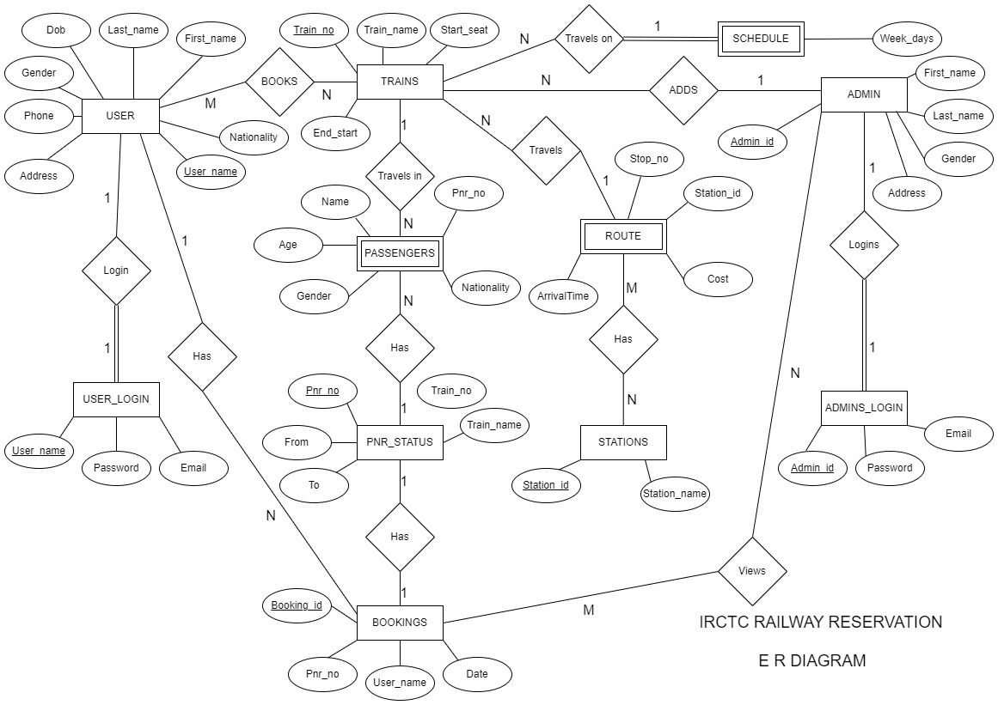

**Fig 3.1 ER Diagram of IRCTC**

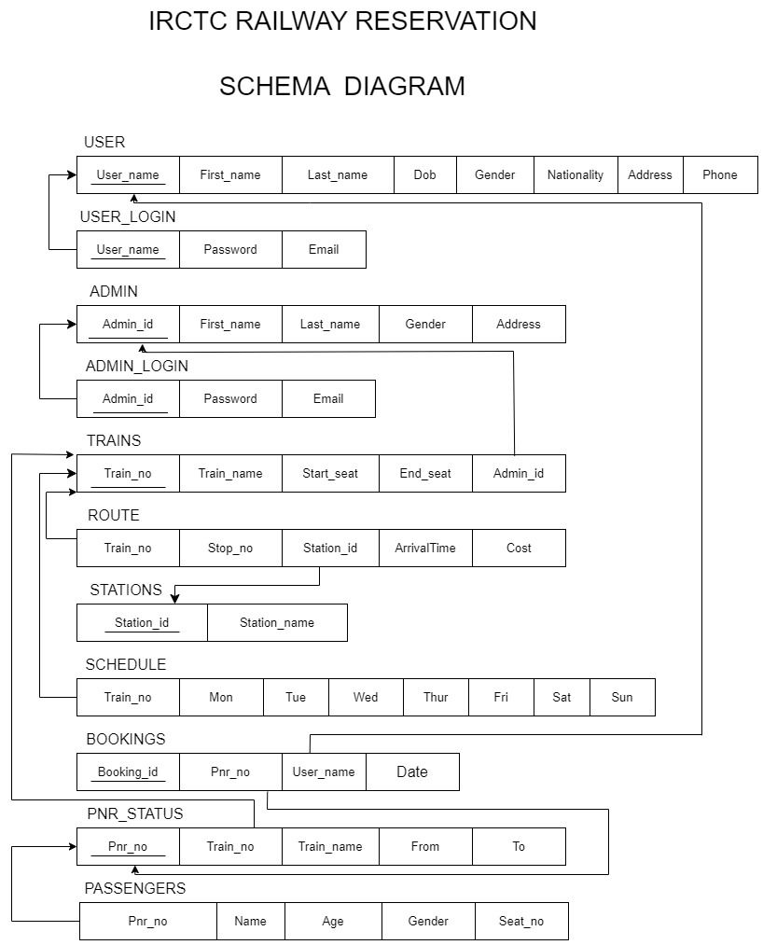

**Fig 3.2 Schema Diagram of IRCTC**

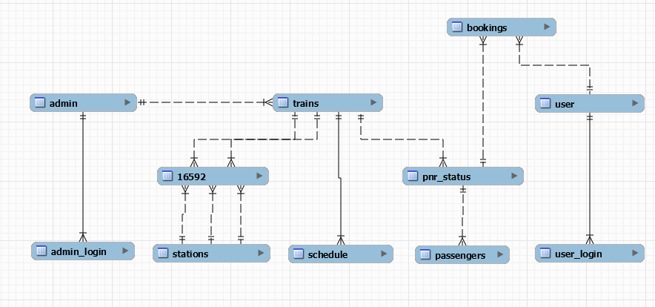

**Fig 3.3 EER Diagram of IRCTC**

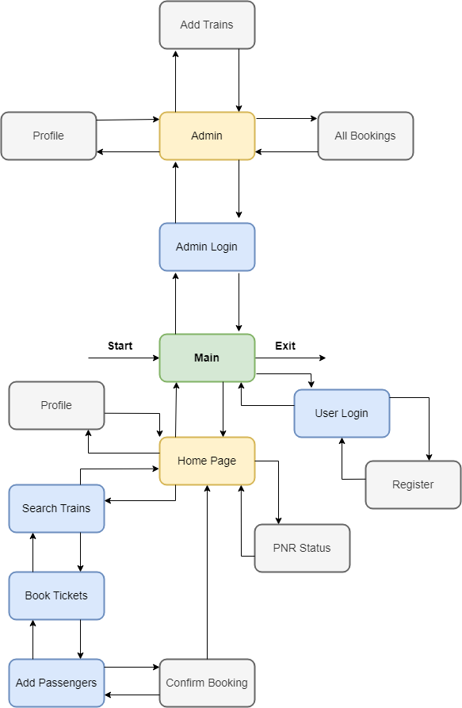

**Fig 3.4 Control Flow Diagram of IRCTC**

**CHAPTER 4**

**IMPLEMENTATION**

**4.1 JAVA**

Java is a widely used object-oriented programming language and software platform that runs on billions of devices, including notebook computers, mobile devices, gaming consoles, medical devices and many others. The rules and syntax of Java are based on the C and C++ languages.

One major advantage of developing software with Java is its portability. Once you have written code for a Java program on a notebook computer, it is very easy to move the code to a mobile device. When the language was invented in 1991 by James Gosling of Sun Microsystems (later acquired by Oracle), the primary goal was to be able to "write once, run anywhere."

It's also important to understand that Java is much different from JavaScript. JavaScript does not need to be compiled, while Java code does need to be compiled. Also, JavaScript only runs on web browsers while Java can be run anywhere.

**4.2 JAVA SWING AND AWT**

AWT and Swing are used to develop window-based applications in Java. Awt is an abstract window toolkit that provides various component classes like Label, Button, TextField, etc., to show window components on the screen. All these classes are part of the Java. Awt package.

On the other hand, Swing is the part of JFC (Java Foundation Classes) built on the top of AWT and written entirely in Java. The javax swing API provides all the component classes like JButton, JTextField, JCheckbox, JMenu, etc.

The components of Swing are platform-independent, i.e., swing doesn't depend on the operating system to show the components. Also, the Swing's components are lightweight. The main differences between [AWT](https://www.javatpoint.com/java-awt) and [Swing](https://www.javatpoint.com/java-swing) are given in the following table.

#### **4.3** **SQL (Structured Query Language)**

SQL (Structured Query Language) is a domain-specific language used in programming and designed for managing data held in a relational database Management system (RDBMS), or for stream processing in a relational data stream management system (RDSMS). In comparison to older read/write APIs like [SAM or VSAM, SQL offers two main advantages: first, it introduced the concept of accessing many records with one single command; and second, it eliminates the need to specify how to reach a record, e.g. with or without an index.

Originally based upon relational algebra and tuple relational calculus, SQL consists of a data definition language, data manipulation language, and data control language. The scope of SQL includes data insert, query, update and delete, schema creation and modification, and data access control. Although SQL is often described as, and to a great extent is, a declarative language (4GL), it also includes procedural elements.

# **4.4 Java JDBC**

JDBC stands for Java Database Connectivity, which is a standard Java API for database-independent connectivity between the Java programming language and a wide range of databases.

The JDBC library includes APIs for each of the tasks mentioned below that are commonly associated with database usage.

* Making a connection to a database.
* Creating SQL or MySQL statements.
* Executing SQL or MySQL queries in the database.
* Viewing & Modifying the resulting records.

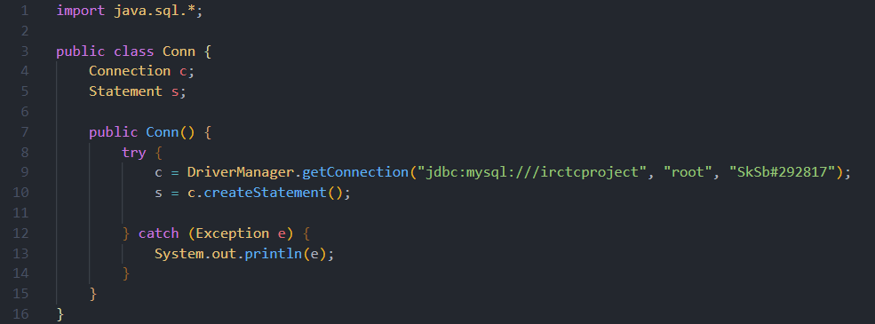

**Fig 4.1 Establish Connection**

**4.5 TALE DESCRIPTIONS**

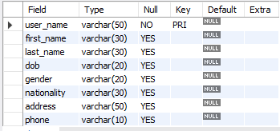**4.5.1 User Table:** Table used to store the user information such as name Date of birth, gender, address etc.

**Table 4-1 User Table**

**4.5.2 User login :** Table used to store username,password and email of user

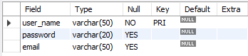

**Table 4-2 user login table**

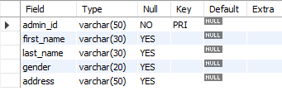**4.5.3 Admin Table:** Table used to store the details of Admin

**Table 4-3 Admin Table**

**4.5.2 Admin login :** Table used to store username,password and email of Admin

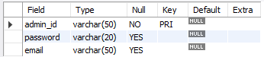

**Table 4-4 Admin Login Table**

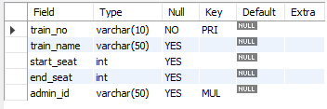**4.5.3 Trains Table:** Table used to store the list of all trains available such as train number, train name, seats available and admin id as foreign key which denotes the admin who has added the train

**Table 4-5 Trains Table**

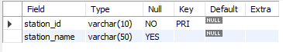**4.5.4 Stations Table:** Table used to store the list of all stations with their station id and station name.

**Table 4-6 Stations Table**

**4.5.5 Routes Table:** Routes table is used to store the stations and order of stops the train travels through and also contains the cost of each stations.

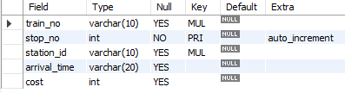

**Table 4-7 Routes table**

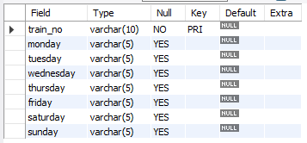**4.5.6 Schedule Table:** Table used to store the schedule of the train. It stores the days in which train travels.

**Table 4-8 Schedule table**

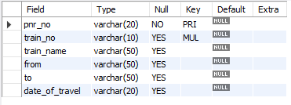**4.5.6 PNR Status table:** This table stores the PNR details of the passengers. PNR number is a unique 10 digit number given to passengers travelling together in a train

**Table 4-9 PNR Status table**

**4.5.7 Bookings Table:** This table stores the booking details of the user which can be identified by a unique Booking Id. The user can access his booking details anytime. Admin can access all the bookings done by all the registered users.

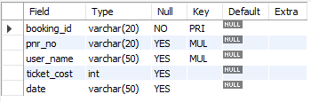

**Table 4-10 Bookings Table**

**4.5.8 Passengers Table:** Passengers table stores the passengers details such as name, gender, age and seat number assigned to the passengers.

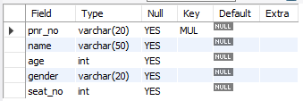

**Table 4-11 Passengers Table**

**4.6 TRIGGERS**

A trigger is a special type of stored procedure that automatically runs when an event occurs in the database server. DML triggers run when a user tries to modify data through a data manipulation language (DML) event.

**4.6.1 Syntax:**

CREATE TRIGGER trigger_name   trigger_time trigger_event

ON table_name FOR EACH ROW

BEGIN

    --variable declarations

    --trigger code

END;

**4.6.2 Trigger for Calculating Cost**

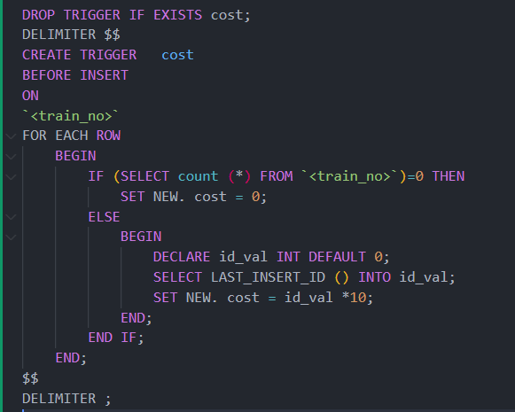

**Fig 4.2 Trigger for calculating cost**

**4.7 STORED PROCEDURE**

A stored procedure is a prepared SQL code that you can save, so the code can be reused over and over again. So if you have an SQL query that you write over and over again, save it as a stored procedure, and then just call it to execute it.

**4.7.1 Syntax**

DELIMITER &&

CREATE PROCEDURE procedure_name [[IN | OUT | INOUT] parameter_name datatype [, parameter datatype]) ]

BEGIN

     Declaration_section

     Executable_section

END &&

DELIMITER ;

**4.7.2 Procedure for listing all the trains available**

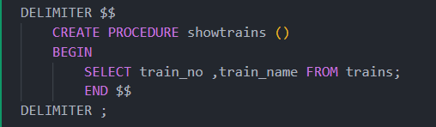

**Fig 4.3 Stored procedure**

**4.7.3 Call a Stored Procedure**

CALL showtrains ();

**CONCLUSION**

**REFERENCES**

1. Java Documentation – <https://docs.oracle.com/en/java/>
2. Stack Overflow – <https://stackoverflow.com/>
3. Stack Exchange – <https://stackexchange.com/>
4. The MySQL Documentation – <https://dev.mysql.com/doc/>
5. Wikipedia – https://[www.wikipedia.org/](http://www.wikipedia.org/)
6. Figma - <https://www.figma.com/>
7. Code for Interview YouTube channel - https://www.youtube.com/c/TheCodingInterview?app=desktop